





**Aggregate Processing Plant**

**Quick Guide Instructions for**

**Iowa EASY Air**

Iowa Department of Natural Resources

Wallace State Office Building

Air Quality Bureau

502 E 9th St

Des Moines, IA 50319

Phone: (515) 725-8200

**Contact the Iowa EASY Air Helpdesk**

**Email:** [**easyair@dnr.iowa.gov**](mailto:easyair@dnr.iowa.gov)

**Or call (515) 725-9569 or** **(515) 204-3749**

# Table of Contents

Table of Contents 2

List of Figures 2

1. Adding the Aggregate Processing Plant Application to Your Account 4

2. Finding the Aggregate Processing Plant Application 7

3. Filling Out and Submitting an Aggregate Processing Plant Application 8

3.1 Facilities Covered by Template Permit 9

3.2 Contact Information 9

3.2.1 Facility Contact Information 9

3.2.2 Facility Information 10

3.3 Emission Limits and Compliance Demonstrations 10

3.3.1 Emission Limits 10

3.3.2 Compliance Demonstrations 11

3.4 Federal Rule Applicability 11

3.5 Operating Limits 11

3.5.1 Emission Point Stack Requirements 11

3.5.2 Operating Limits 11

3.5.3 Best Management Practices 12

3.6 Equipment List 12

3.7 Form GHG: Greenhouse Gas Emissions Inventory 13

3.8 Attachments 15

3.9 Validation 17

3.10 Payment 18

3.11 Submission 19

Appendix A – Sample Equipment List 21

# List of Figures

Figure 1 Dashboard Buttons to Create a New Submittal 4

Figure 2 Submittal Menu 4

Figure 3 Link to Submittal Types Associated with my Account 5

Figure 4 Available Submittal Types 5

Figure 5 My Account Menu 6

Figure 6 Basic Information Tabs 6

Figure 7 Associate Facility Button 6

Figure 8 Associate Facility Search 7

Figure 9 Facility Search Results and Adding Submission Type 7

Figure 10 Dashboard Buttons to Create a New Submittal 8

Figure 11 Submittal Menu 8

Figure 12 Construction – Aggregate Processing Plant Icon 8

Figure 13 Facilities Covered by Template Permit Statement 9

Figure 14 Facility Contact Information 9

Figure 15 Facility Information 10

Figure 16 Emission Limits Statement 10

Figure 17 Emission Limits Statement 11

Figure 18 Federal Rule Applicability Statement 11

Figure 19 Emission Point Stack Requirements Statement 11

Figure 20 Operating Limits Statement 11

Figure 21 Best Management Practices Statement 12

Figure 22 Equipment List Summary 12

Figure 23 Equipment List Summary 12

Figure 24 Equipment List Example 13

Figure 25 Form GHG: Greenhouse Gas Emissions Inventory Summary 14

Figure 26 Attachment Screen 16

Figure 27 Attachment Screen 16

Figure 28 Example Attachment Screen 17

Figure 29 Example Validation Screen 18

Figure 30 Example Payment Screen 18

Figure 31 Example Certificate of Submission Screen 19

Figure 32 Confirmation of Submittal 20

This document provides directions on how to apply for an Aggregate Processing Plant Template Permit in the Iowa EASY Air System.

(Note: This document is written to explain how a Responsible Official can submit an application for a template permit for an Aggregate Processing Plant. As with other submittal types within the Iowa EASY Air system, the Responsible Official may delegate the completion of these forms to a Preparer. The Preparer can complete the forms and have the Responsible Official complete the certification and submit the template application. The instructions for assigning a Preparer for a facility and submittal type are covered in other parts of the Iowa EASY Air documentation.)

# Adding the Aggregate Processing Plant Application to Your Account

Before you are able to apply for a template permit for an Aggregate Processing Plant in the Iowa EASY Air system, you will need to add the Aggregate Processing Plant application to your account.

**Viewing Associated Application Types**

If you do not know what application types are associated to your account, you may navigate to the Air Department Submittal Type List page and view the submittal types associated with your account. There are two ways to the Air Department Submittal Type List page within the Iowa EASY Air system.

For one method, on your dashboard click on the “Apply for a New Submittal” button in the upper left-hand corner of the dashboard as shown in Figure 1.

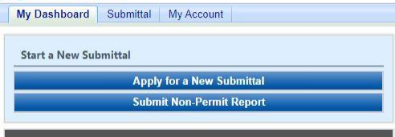

Figure 1 Dashboard Buttons to Create a New Submittal

Alternatively, hover over the Submittal dropdown menu and select “Start a New Submittal” as shown in Figure 2.

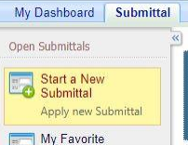

Figure 2 Submittal Menu

Next, you will see the application icons for the different types of submittals available to you in the system as shown in Figure 3.

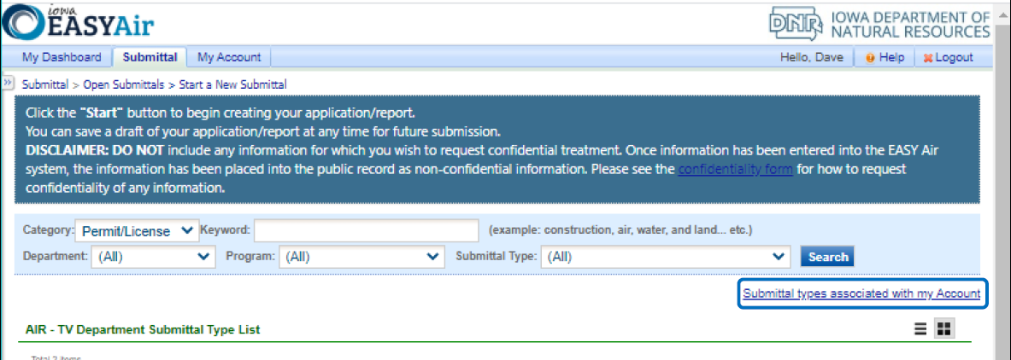

Figure 3 Link to Submittal Types Associated with my Account

Next, click on the link labeled “Submittal types associated with my Account” on the right side of the screen and the “Available Submittal Types” screen will appear as shown in Figure 4. On this screen, you are able to view the available submittal types and the submittal types already associated with your account.

A screenshot of the "Available Submittal Types". Two sections are shown, the "Available Submittal Types" and "Submittal Type Association Instruction".

Figure 4 Available Submittal Types

If you don’t see the Aggregate Processing Plant application associated with your account, click on “Add More”. This will take you to the “Basic Information” page. Follow the instructions below to associate the application type.

**Associate an Application Type**

To associate an application type to your account, you will need to navigate to the “Associate Facilities” tab. To navigate to the “Associate Facilities” tab, on your dashboard hover on “My Account” and click on “Basic Information” as shown in Figure 5.

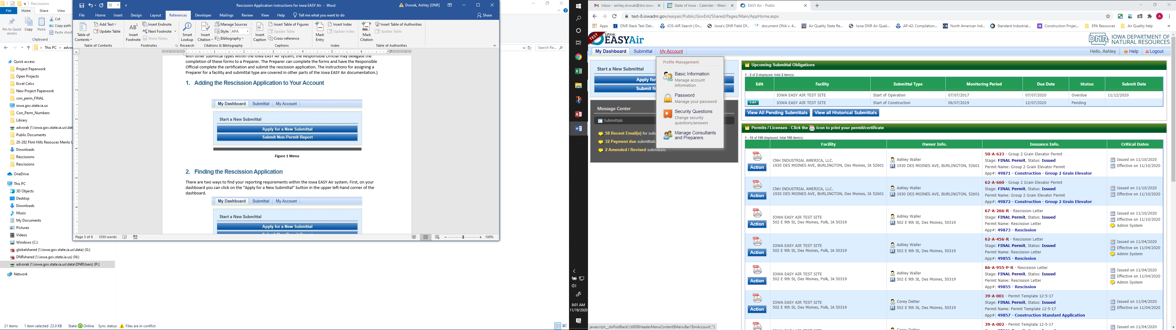

Figure 5 My Account Menu

The Basic Information page will appear. As shown in Figure 6, this page will have four tabs on top. Click on the “Associate Facilities” tab. This tab will show all your associated facilities and application types you currently have on your account.

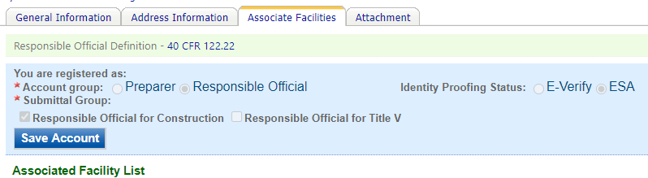

Figure 6 Basic Information Tabs

Next, scroll to the bottom of the page and you should see three buttons, as shown in Figure 7 below. Please click on “Associate Facility”.

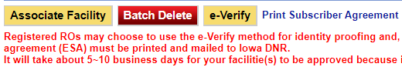

Figure 7 Associate Facility Button

The facility search will appear as shown in Figure 8 below. Enter in your facility information and click, “Search”. You may search by Facility Name, Address, or Facility Number.

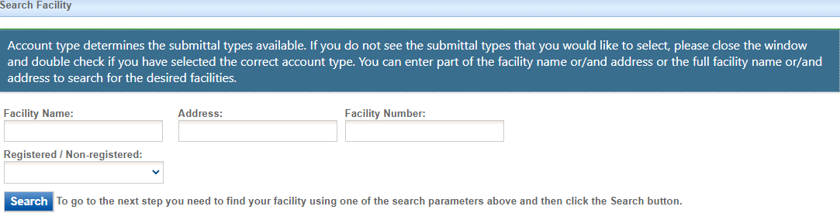

Figure 8 Associate Facility Search

The facility information will appear below the facility search as shown in Figure 9. Select the check box for the facility and the “Construction – Aggregate Processing Plant” check box under submission type.

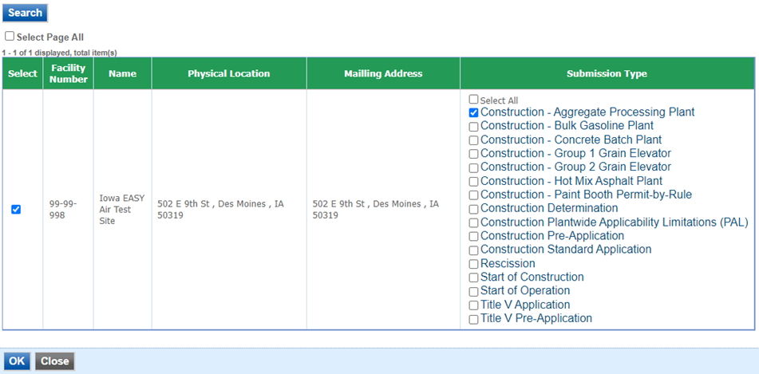

Figure 9 Facility Search Results and Adding Submission Type

Next, click “Ok” and then click “Close”. This will associate the Aggregate Processing Plant application to your account. If you went through the e-Verify subscriber agreement process when you set up your account, you will be able to use the Aggregate Processing Plant application after this step. However, if you sent in the paper subscriber agreement form, you will have to wait until the Iowa EASY Air Administrator completes the association of the Aggregate Processing Plant application to your account. You will receive an email from the Iowa EASY Air Administrator when the association of the Aggregate Processing Plant application has been made to your account.

# Finding the Aggregate Processing Plant Application

There are two ways to start an application within the Iowa EASY Air system. For one method, on your dashboard you can click on the “Apply for a New Submittal” button in the upper left-hand corner of the dashboard as shown in Figure 10.



Figure 10 Dashboard Buttons to Create a New Submittal

Alternatively, hover over the “Submittal” tab and select “Start a New Submittal” as shown in Figure 11.



Figure 11 Submittal Menu

Next, you will see the application icons for the different types of submittals available to you in the system. The Construction – Aggregate Processing Plant icon is shown below in Figure 12. Please select “Start” at the bottom right hand corner of the icon to start the Aggregate Processing Plant application.

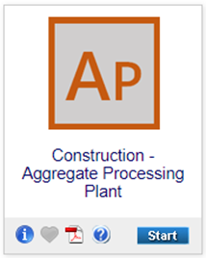

Figure 12 Construction – Aggregate Processing Plant Icon

# Filling Out and Submitting an Aggregate Processing Plant Application

In order to apply for a permit for an Aggregate Processing Plant using the template, you must first verify that the proposed facility meets the limitations contained in the template. The Iowa EASY Air application has been designed to walk you through each part of the template permit to verify that the proposed facility will meet the limitations established in the template permit, to assist the Department in drafting your permit. The permit will not be valid until reviewed and issued by the Department.

No changes may be made to any of the conditions. If you cannot meet those conditions or want to operate differently, you should complete a Construction Standard Application for each emission unit at the facility.

## Facilities Covered by Template Permit

Next the Facility Covered by Template Permit screen will appear (see Figure 13). Please read the Facilities Covered by Template Permit screen carefully to be certain you can meet the conditions contained therein. Once you have reviewed the conditions and have determined that the template is applicable to your facility, please check the box at the bottom that you have read the statement, then click on “Save” and then “Next”.

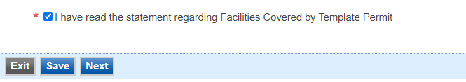

Figure 13 Facilities Covered by Template Permit Statement

## Contact Information

Next the Contact Information screen will appear (see Figure 14 and 15).

#### Facility Contact Information

Please provide the name and contact information for the person within the company who should be contacted regarding questions or other pertinent information related to the permit application. If this person is the responsible official, please check the box stating this. All fields with a red asterisk are required to be filled in.

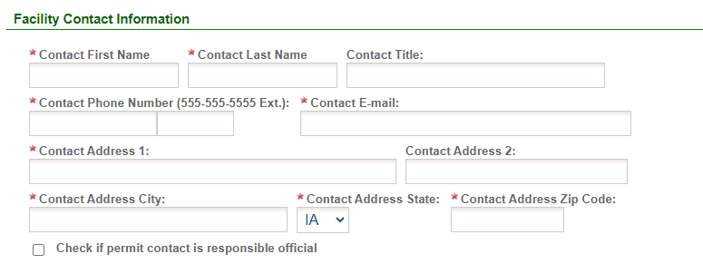

Figure 14 Facility Contact Information

#### Facility Information

Please click on the “Company/Facility Name:” dropdown box and select the Company/Facility Name that the permit should be associated to. The facility address and facility number will auto-fill. If the facility information is not correct, please contact [easyair@dnr.iowa.gov](mailto:easyair@dnr.iowa.gov) to change the facility information.

Next, select whether the equipment is portable. If you answered “Yes”, provide the staging area address information. If you answered “No”, provide the permanent location address information. If you select “Same as Facility Address”, the information will be copied from the facility address information.

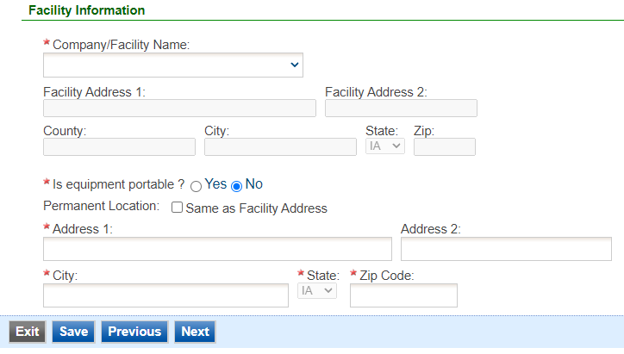

Figure 15 Facility Information

Once you have finished entering the information, click “Save” and then “Next”. If there is required information missing from the section, the Iowa EASY Air system will highlight the required fields in red. You may proceed with the application, but the system will not allow you to submit the application until all the required fields are completed during the Validation step.

## Emission Limits and Compliance Demonstrations

Next the Emission Limits and Compliance Demonstrations screen will appear (see Figure 16 and 17).

#### Emission Limits

Please read the Emission Limits section carefully to be certain you can meet the conditions contained therein. Once you have reviewed the conditions and have determined that the template is applicable to your facility, please check the box at the bottom that you have read the section.

A screenshot of a checkbox reading "I have read the emission limit requirements."

Figure 16 Emission Limits Statement

#### Compliance Demonstrations

Please read the Compliance Demonstrations section carefully to be certain you can meet the conditions contained therein. Once you have reviewed the conditions and have determined that the template is applicable to your facility, please check the box at the bottom that you have read the section, then click on “Save” and then “Next”.

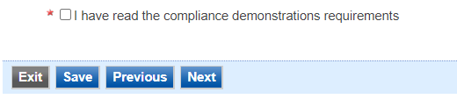

Figure 17 Emission Limits Statement

## Federal Rule Applicability

Next the Federal Rule Applicability screen will appear (see Figure 18). Please read the Federal Rule Applicability screen carefully to be certain you can meet the conditions contained therein. Once you have reviewed the conditions and have determined that the template is applicable to your facility, please check the box at the bottom that you have read the section, then click on “Save” and then “Next”.

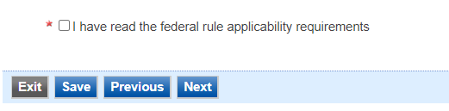

Figure 18 Federal Rule Applicability Statement

## Operating Limits

Next the Operating Limits screen will appear (see Figure 19, 20, and 21).

#### Emission Point Stack Requirements

Please read the Emission Point Stack Requirements section carefully to be certain you can meet the conditions contained therein. Once you have reviewed the conditions and have determined that the template is applicable to your facility, please check the box at the bottom that you have read the section.

A screenshot of a checkbox reading "I have read the emission point stack requirements."

Figure 19 Emission Point Stack Requirements Statement

#### Operating Limits

Please read the Operating Limits section carefully to be certain you can meet the conditions contained therein. Once you have reviewed the conditions and have determined that the template is applicable to your facility, please check the box at the bottom that you have read the section.

A screenshot of a checkbox reading "I have read the general operating limits requirements."

Figure 20 Operating Limits Statement

#### Best Management Practices

Please read the Best Management Practices section carefully to be certain you can meet the conditions contained therein. Once you have reviewed the conditions and have determined that the template is applicable to your facility, please check the box at the bottom that you have read the section, then click on “Save” and then “Next”.

A screenshot of a checkbox reading 
"I have read the best management practices requirements."

Figure 21 Best Management Practices Statement

## Equipment List

Next the Equipment List screen will appear as shown in Figure 22. To enter the equipment associated with your Aggregate Processing Plant, click “Add New Record”. Text boxes for the Production Equipment Type, Production Equipment Make, Production Equipment Model, Production Equipment (Serial Number/Company ID), Associated Control Equipment (Serial Number/Company ID), and Construction Date will appear as shown in Figure 23.

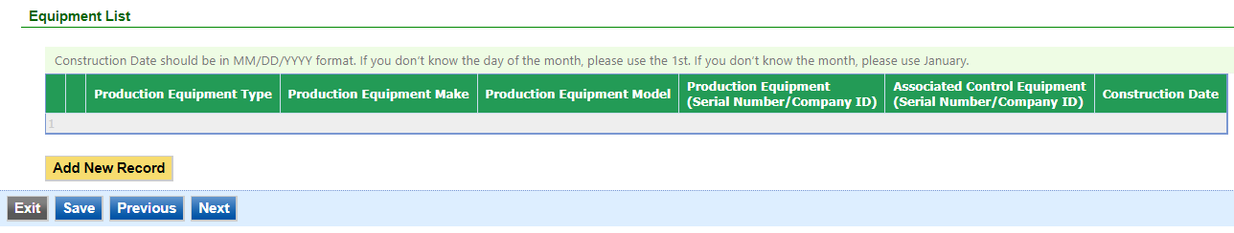

Figure 22 Equipment List Summary

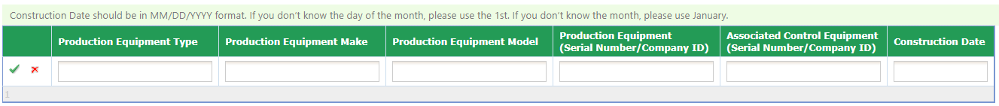

Figure 23 Equipment List Summary

Please enter the information in each text box for each equipment for the proposed Aggregate Processing Plant. An example equipment list is attached for reference in Appendix A. This example equipment list uses typical Concrete Batch Plant equipment as an example, therefore the equipment may not be similar to an Aggregate Processing Plant.

When you are finished with entering information for a piece of equipment equipment, click the green “checkmark” to add the equipment to the list. If you need to remove equipment from the list, you may click the red “x” to delete the equipment from the list.

Below is an explanation for the corresponding field on the form:

**Production Equipment Type:** Provide the name of the equipment type that is a part of the Aggregate Processing Plant, such as “Crusher”, “Aggregate Conveyors”, “Storage Bin”, etc.

**Production Equipment Make:** Provide the name of the manufacturer of the process equipment. If unknown, list “Unknown”.

**Production Equipment Model:** Provide the name of the model of the process equipment. If unknown, list “Unknown”.

**Production Equipment (Serial Number/Company ID):** Provide the identifier that the facility will use for this equipment. This may either be the serial number of the process equipment, a specific company ID that the facility uses for this equipment, or an Emission Unit (EU) ID.

**Associated Control Equipment (Serial Number/Company ID):** If the source is controlled by an air pollution control device (ex: baghouse, dust collector, etc.), provide a description of the control equipment along with an identifier that the facility will use for this equipment. This may either be the serial number of the control equipment, a specific company ID that the facility uses for this equipment, or a Control Equipment ID.

**Construction Date:** The Construction Date should be the date the equipment was manufactured. The date should be in MM/DD/YYYY format. If you don’t know the day of the month, please use the 1st of the known month. If you don’t know the month of the year, please use January 1st of the known year.

Please click “save” at the bottom of the screen to save the equipment description(s) to the application.

If you do not click “save” before loading into another page, you will lose your current progress entering information.

Once you have entered equipment to the list and confirmed it with the green “checkmark”, you may edit the equipment using the “pencil and paper” icon, or delete the record using the “red x” icon shown below in Figure 24. If you choose to delete the record, the Iowa EASY Air system will confirm that you want to delete the record with a pop-up message. Select “Ok” on this message to confirm, or “Cancel” to stop the deletion request.

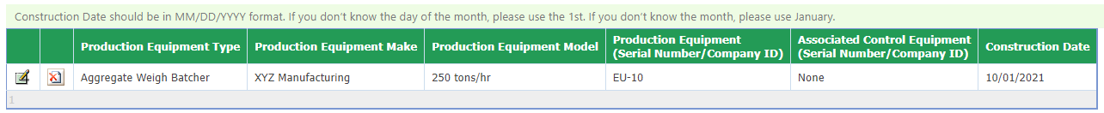

Figure 24 Equipment List Example

When you are finished filling out this form, please click, “Save” and then “Next”. In addition, please click “Save”, if you want to save your work and return to the form to complete at a later time.

## Form GHG: Greenhouse Gas Emissions Inventory

Next the Form GHG: Greenhouse Gas Emissions Inventory screen will appear as shown in Figure 25.

As required by IAC 455B.134(3)”f”, Form GHG is required for every construction permit application even if the potential GHG emissions are zero.

GHG emissions are caused by combustion sources (e.g. dryers, boilers, space heaters, etc.). If your application does not have any Greenhouse Gas (GHG) emissions, please check the corresponding box at the top of the screen. The rest of the form does not need to be completed.

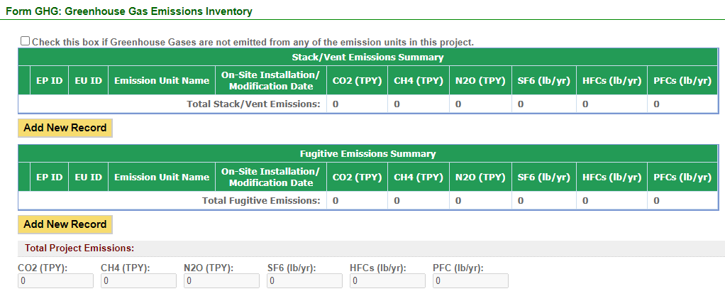

Figure 25 Form GHG: Greenhouse Gas Emissions Inventory Summary

If GHG emissions are present:

* To begin entering information for each emission unit, use the “Add New Record” button.
* List ALL emission units in the project including fugitive sources, exempt units and other non-permitted emission units (i.e. natural gas boilers rated less than 10 MMBtu/hr, chillers, small units, etc.). Mobile sources (i.e. trucks, forklifts, cars, etc.) are not required to be listed.
* Emission units may be grouped into categories (i.e. chillers, space heaters, etc.).
* If the project is a modification to an emission unit, the facility shall report the total GHG emissions for the unit.
* If multiple emission units use a common emission point, associate the emission point ID in column (1) to each of the emission units involved in column (2). Provide the GHG emissions for each unit venting to that emission point.
* Show how potential GHG emissions were calculated on an attached sheet labeled “Form GHG-A”. Total HFCs and PFCs are to be listed in the corresponding cells, but the calculations should separate the individual HFCs and PFCs.
* More information concerning GHG emissions, including emission factors, can be found on the Air Quality Bureau [Greenhouse Gas Emission page](https://www.iowadnr.gov/Environmental-Protection/Air-Quality/Greenhouse-Gas-Emissions).

Below is an explanation for the corresponding field on the form:

**Emission Point (EP) ID:** Called the emission point (EP) identification (ID). It can be any combination of letters or numbers up to 16 characters in length. The ID should match the ID for this equipment used on other construction permit applications and within this application. If also submitting an operating permit application, the ID used in this application should be consistent with those used in the operating permit application.

**Emission Unit (EU) ID:** Called the emissions unit (EU) identification (ID). Each source in the application must have its own identifier. It can be any combination of letters or numbers up to 16 characters in length. The ID should match the ID for this equipment used on other construction permit applications and within this application. If also submitting an operating permit application, the ID used in this application should be consistent with those used in the operating permit application.

**Emission Unit Name:** Provide the name of the emission unit, such as “Emergency Engine”, “Boiler 1”, etc.

**On-Site Installation or Modification Date:** Provide the date (both month and year) in which on-site installation or modification of the emission unit begins or will begin.

* For the purposes of this form: Modification means any physical change or change in the method of operation of any existing equipment or control equipment.
* If you don’t know the day of the month, please use the 1st of the known month. If you don’t know the month of the year, please use January 1st of the known year.

**Potential or Permitted Emission Rate:** Fill in the rate of potential emission in the appropriate units (either tons per year or pounds per year) for each pollutant. The following are the GHG emissions that must be included:

CO2: Carbon dioxide

CH4: Methane

N2O: Nitrous oxide, also known as dinitrogen oxide or dinitrogen monoxide.

SF6: Sulfur hexafluoride

HFC: Hydrofluorocarbons

PFC: Perfluorocarbons

Attach to this form a copy of your calculations showing how the potential GHG emissions were calculated.

Total HFCs and PFCs are to be listed in the corresponding cells, but the calculations should separate the individual HFCs and PFCs. If you have more stack/vent emission sources than can fit on this form, attach a separate sheet labeled “Form GHG-A”.

There is a separate field area for fugitive emissions on this screen. Fugitive emissions are those emissions that cannot reasonably be made to pass through a stack, vent, or equivalent opening. Examples include equipment leaks, portion of landfill gas emissions, portion of wastewater treatment plant emissions, transformers, etc. Fugitive emissions must be included on this form if they are part of the current project for which the application is being submitted.

The system will automatically sum all the potential or permitted emission rates for the listed equipment. To remove an entry in the Stack/Vent Emissions Summary table or the Fugitive Emissions Summary table, click the red “x”. The Iowa EASY Air system will confirm with you that you want to delete the record with a pop-up message. Select “Ok” on this message to confirm, or “Cancel” to stop the deletion request. Please click “save” at the bottom of the screen to save the data entered into each table to the application.

If you do not click “save” before loading into another page, you will lose your current progress entering information.

## Attachments

Next the Attachments screen will appear (see Figure 26). Attachments may be uploaded to the application electronically, or mailed/faxed to the Department.

The Iowa DNR recommends that attachments be submitted electronically so as to not slow down the application process.

Please attach any documents required to assist the assigned engineer with completing the project on this screen.

To include your attachment(s) in the Iowa EASY Air system, select the “Online” radio button and then click on the “Upload” button. Only one file may be uploaded at a time, and the maximum file size allowed is 100 MB.

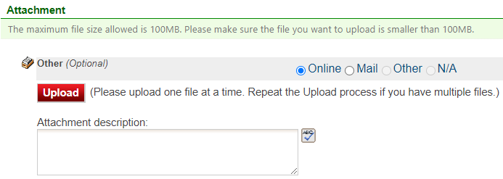

Figure 26 Attachment Screen

Select “Choose File” to select the document to be uploaded (see Figure 27). These file types are accepted by the system:

* pdf, doc, docx, txt, xls, xlsx, cvs
* jpeg, jpg, bmp, png, gif
* xml

You may include a comment for each attachment. When you have successfully selected the document, click on “Save” to upload the attachment.

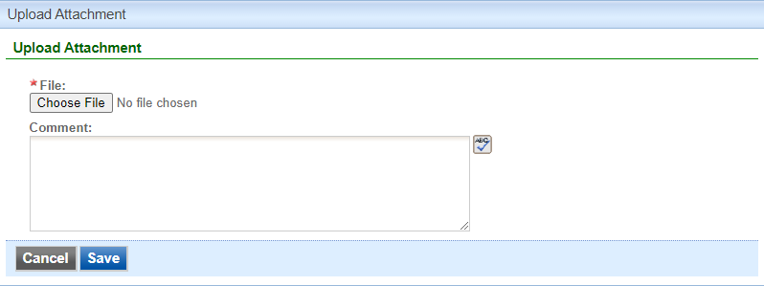

Figure 27 Attachment Screen

The uploaded attachment will display on the screen as shown in Figure 28. To remove an attachment, click the red “x” icon. The Iowa EASY Air system will confirm with you that you want to delete the record with a pop-up message. Select “Ok” on this message to confirm, or “Cancel” to stop the deletion request. To edit the attachment comment, click on the attachment comment, edit the comment, then select “Save” to update the comment or “Cancel” to cancel the change.

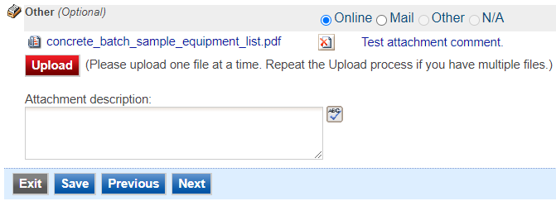

Figure 28 Example Attachment Screen

Please click “save” at the bottom of the screen to save the page.

If you do not click “save” before loading into another page, you will lose your current progress entering information.

If you plan to mail or fax the attachments, please select the “Mail” radio button on the attachment screen. If mailing attachments, include the attachment descriptions and submittal ID. Mail attachments to the following address:

Application Login Desk

Air Quality Bureau

502 E 9th Street

Des Moines, IA 50319

If faxing documents, include the attachment descriptions and submittal ID. The Air Quality Bureau fax number is (515) 725-9501.

## Validation

Next the Validation screen will appear (see Figure 29). The system will check the application forms for required information that is missing, and will display a result similar to the figure below:

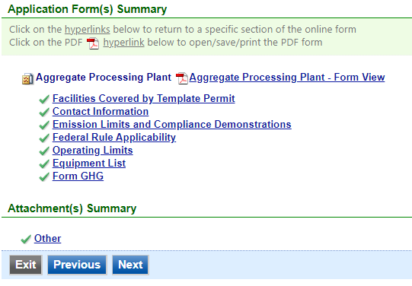

Figure 29 Example Validation Screen

If there are no noted issues, click the “Next” button. If there are issues, you may navigate to the section by selecting the section on this screen to complete the missing information.

Please note that the system will only check for missing information, and will not validate whether the information is complete or accurate.

## Payment

Next the Payment screen will appear (see Figure 30). The application fee for an Aggregate Processing Plant template permit is $100.00 per application for each plant. You may pay for the application fee by Credit Card, Check, Money Order, or eCheck (ACH – NACHA).

The Iowa DNR recommends that payment be submitted electronically (Credit Card or eCheck) so as to not slow down the application process.

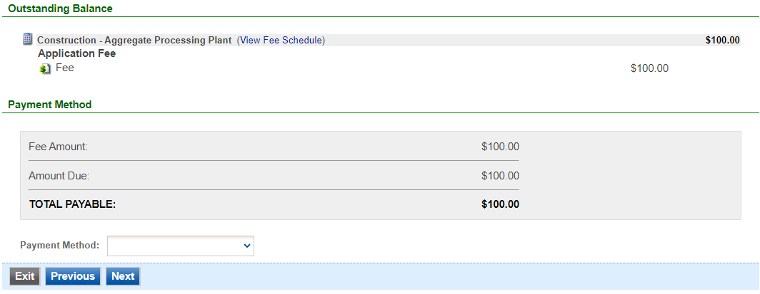

Figure 30 Example Payment Screen

If paying by Credit Card or eCheck, please use the “Online Checkout” option in the dropdown menu. The system will request the applicable information for each type of payment. If paying by Check or Money Order, select the appropriate method in the dropdown menu. When sending the payment via mail, please use the following information for payment:

* Pay To: Iowa Department of Natural Resources
* Address: Wallace State Office Building 502 E 9th St, 4th Floor, Des Moines IA 50319
* Please print a copy of the submittal receipt and mail it in with the payment or write the submittal ID number on the check or money order.

When you have finished, click the “Next” button.

## Submission

Next, the Certification of Submission screen will appear (see Figure 31). Please review the statement at the top of the screen, then check the box at the top of the screen, answer the security question, enter your pin, and click “Submit”.

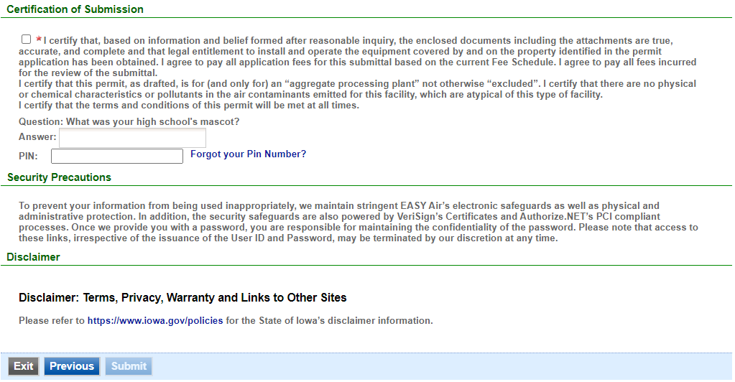

Figure 31 Example Certificate of Submission Screen

You will get a confirmation screen similar to the one shown below in Figure 32 and a confirmation email will be sent to you.

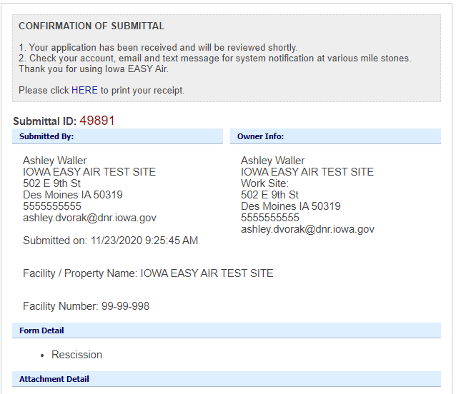

Figure 32 Confirmation of Submittal

**If you have questions, please call the Iowa EASY Air Helpdesk  
at (515) 725-9569 or (515) 204-3749.**

**Or, send an email to** [**easyair@dnr.iowa.gov**](mailto:easyair@dnr.iowa.gov)

Appendix A – Sample Equipment List

